**Programs**

**1.. Familiarizing Text Editor, IDE, Code Analysis Tools etc // Use any IDE**

**Pycharm**

-specialized project views allowing quick switching between files.

-facilitates web development along with Django flask and web 2py.

**Eric**

-build-in support for Django.

-code fielding.

-Format syntax highlighting,

**Thonny**

-separate windows are provided to execute function calls.

-statement stepping without break points.

**2. Display future leap years from current year to a final year entered by user.**

c=int(input("enter current year"))

f=int(input("enter final year"))

if(c<f):

print("leap year:",end=" ")

for i in range(c,f):

if(i%4==0 and i%100!=0):

print(i,end=" ")

**output:**

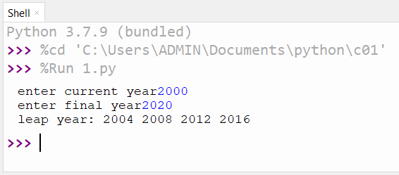

3..**List comprehensions:**

**a)Generate positive list of numbers from a given list of integers**

list=[1,3,-4,-8,9]

p=[n for n in list if n>=0]

print(p)

**output:**

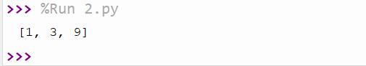

b)**Square of N number**

n=int(input("enter a limit"))

s=[i**2 for i in range(1,n)]

print("square is:",s,end=" ")

**output:**

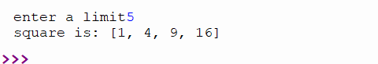

c)**Form a list of vowels selected from a given word**

n=str(input("enter a string"))

for i in n:

if i in"aeiouAEIOU":

print(i)

**output:**

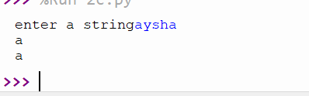

**d)value of each element of a word (Hint: use ord() to get ordinal values)**

n=str(input("enter a str"))

for i in n:

print(ord(i),end=" ")

**output:**

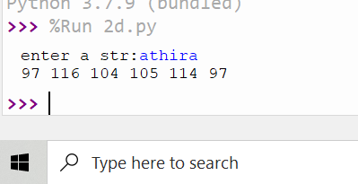

4.**Count the occurrences of each word in a line of text.**

str1 = input("Enter a string : ")

wordlist = str1.split()

count= []

for w in wordlist: count.append(wordlist.count(w))

print("count of the occurrence:" + str(list(zip(wordlist, count))))

**ouput:**

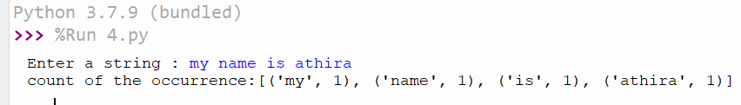

5.**Prompt the user for a list of integers. For all values greater than 100, store ‘over’ instead**

n=[]

s=int(input("enter a limit"))

print("enter values")

for i in range(0,s):

n.append(int(input()))

print(" values after\n")

for i in range(0,len(n)):

if n[i]>=100:

print("over")

else:

print(n[i])

**output:**

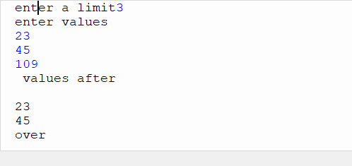

6.**. Store a list of first names. Count the occurrences of ‘a’ within the list**

list=['athira','frd','abc','a','a']

l1=list.count("a")

print("occurence",l1)

**output:**

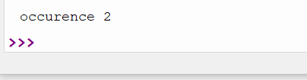

7.. **Enter 2 lists of integers. Check (a) Whether list are of same length (b) whether list sums to same value (c) whether any value occur in both**

lst=[1,3,5,7,9,11,4]

lst1=[5,13,5,7,0,6,1]

s=int(0)

c=int(0)

if(len(lst)==len(lst1)):

print("Lists are of same length")

else:

print("Lists have different length")

for i in range(0,len(lst) and len(lst1)):

s=s+lst[i]

c=c+lst1[i]

if(s==c):

print("equal sum")

else:

print("not same sum")

print("Elements that matched are:")

l=[]

for i in range(0,len(lst)):

for j in range(0,len(lst1)):

if lst[i]==lst1[j]:

l.append(lst[i] and lst1[j])

else:

continue

print(l)

**output:**

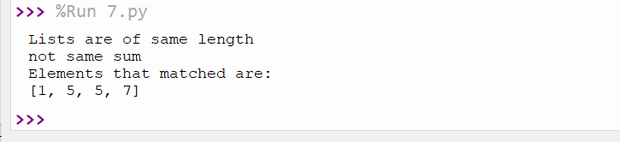

**8..Get a string from an input string where all occurrences of first character replaced with ‘$’, except first character. [eg: onion -> oni$n]**

str="athira"

char=str[0]

str=str.replace(char,'$')

str=char + str[1:]

print(str)

**output:**

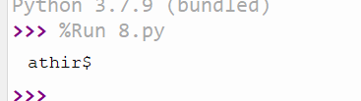

9.**Create a string from given string where first and last characters exchanged. [eg: python -> nythop]**

str=input("enter a string")

str1=str[-1:]+str[1:-1]+str[:1]

print("string is",str1)

**output:**

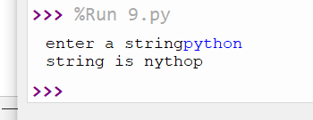

**10.Accept the radius from user and find area of circle.**

pi=3.14

r=int(input("enter radius"))

a=pi*r*r

print("area",a)

**output:**

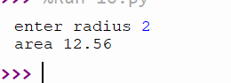

**11.Find biggest of 3 numbers entered**

a=int(input("enter a number"))

b=int(input("enter a number"))

c=int(input("enter a number"))

if(a>b and a>c):

print("a is the largest:",a)

elif(b>c):

print("b is the largest:",b)

else:

print("c is the largest:",c)

**output:**

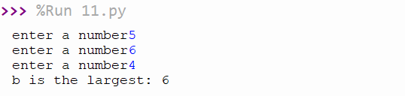

12.**Accept a file name from user and print extension of that**

x,y=(input("enter a file:").split('.'))

print("file extension:",y)

**output:**

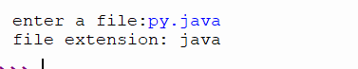

**13.Create a list of colors from comma-separated color names entered by user.Display first and last colors**

a=[]

for i in range(3):

b=input("enter the color:")

a.append(b)

print(a)

print(a[0])

print(a[2])

**output:**

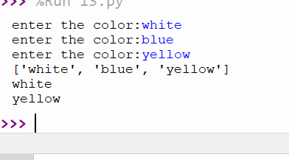

14.**Accept an integer n and compute n+nn+nnn**

n=input("enter number")

x=int(n+n+n)

y=int(n+n)

z=int(n)

print(x+y+z)

**ouput**:

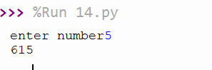

15.**Print out all colors from color-list1 not contained in color-list2.**

list1=set(['red','white','blue'])

list2=set(['green','black','red'])

print(list1.difference(list2))

**output:**

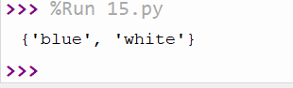

16.**Create a single string separated with space from two strings by swapping the character at position 1.**

a="thir"

b="damu"

p1=a[0]

p2=b[0]

c=b[0]+a[1:]+" "+ a[-4]+b[1:]

print(c)

**output:**

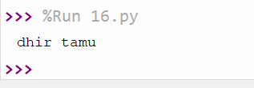

**17.** **Sort dictionary in ascending and descending order**

import operator

d = {1: 2, 3: 4, 4: 3, 2: 1, 0: 0}

print('Original dictionary : ',d)

sorted_d = sorted(d.items(), key=operator.itemgetter(1))

print('Dictionary in ascending order by value ',sorted_d)

sorted_d = dict( sorted(d.items(), key=operator.itemgetter(1),reverse=True))

print('Dictionary in descending order by value : ',sorted_d)

output:

]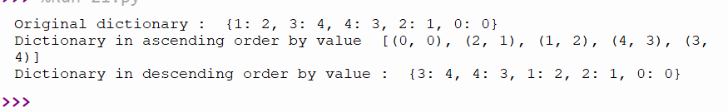

**18. Merge two dictionaries**

a={'name':'athira','age':21}

b={'palce':'koolivayal',"mob":345324647}

print("1 dictionary:",a)

print("2 dictionary:",b)

c=a.copy()

c.update(b)

print("merged",c)

**output:**

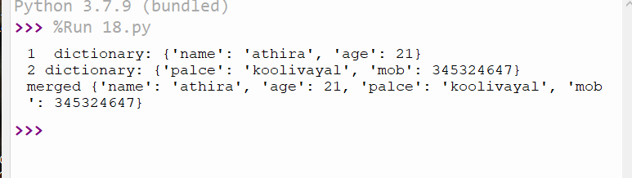

**19.Find gcd of 2 numbers.**

a=int(input("enter a number"))

b=int(input("enter a number"))

i=1

while(i<=a and i<=b):

if(a%i==0 and b%i==0):

gcd=i

i=i+1

print("gcd",gcd)

**output:**

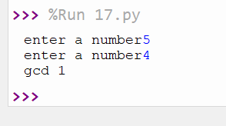

**20.From a list of integers, create a list removing even numbers.**

n=[2,3,6,7,9,4,8]

n=[x for x in n if x%2!=0]

print("nos after removing",n)

**output:**

